Simplifying & Speeding up Data Access: Moving Research Data Scotland (RDS) into operations and towards a sustainable business model
Research Data Scotland: 2023-24 business plan
17 May 2023

Purpose
This document summarises our strategic ambition and key tasks for 2023-24, how we’ll use our income to deliver those priorities, and how this supports our longer-term strategy.

RDS vision
Our vision is to promote and advance health and social wellbeing in Scotland by enabling access to public sector data about people, places and businesses, and creating the conditions for collaborative data-driven research and innovation in the public good using that data.

RDS mission
To achieve our vision, Research Data Scotland (RDS) needs to coordinate access to the excellent data already collected about people, places, and businesses in Scotland, helping researchers and analysts to access that data in a timely and cost-effective way, enable working across boundaries to collaborate on common datasets, and access to the analytical tools they need to bring cutting edge insights that inform great decisions. We will enable research on different scales: from large international studies, to simple and quick analyses of individual datasets, and support people to use the latest data science and geospatial approaches.
RDS will build a portfolio of research data assets that are held securely – with public support – and enable these datasets to be up to date and accessed at pace. RDS will introduce new services that helps organisations to understand the impact of decisions they make and better hones their improvement of wellbeing and equalities.

Progress over the last year
We have made significant progress in the last year, with the input and support of our partner organisations.

Strengthening collaboration, demonstrating trustworthiness
At the heart of what we do is the trust from the public, and data owners to handle their data responsibly. We have established an approach for involving and engaging the public, bringing together a network of people around this topic, establishing a small fund to promote innovation, and collaborated with Administrative Data Research (ADR) Scotland on a deliberative public panel. We have also launched a public engagement fund, and started to play a role in wider activities, such as Data & Intelligence Network, led by Scottish Government (SG); and Public Engagement in Data Research Initiative (PEDRI) led by Health Data Research UK (HDR UK).
The services RDS delivers will be carried out by RDS founding partners: Public Health Scotland (PHS), National Records of Scotland (NRS), and Edinburgh Parallel Computing Centre (EPCC). We have worked with them to clarify roles and system wide priorities. This includes establishing a Scottish Data for Research Alliance to prioritise and deliver system improvements.
Important members of this Alliance are the teams delivering the ADR Scotland programme (Scottish Government and the Scottish Centre for Administrative Data Research). We have confirmed a significant role for RDS in delivering data to be used in the programme.
We have mapped the network of RDS stakeholders and put in place arrangements for engagement and communications with those people. This has included running a quarterly user and stakeholder forum and introducing a monthly newsletter to over 800 people on our mailing list.
RDS has been collaborating with Scottish Government on a number of policy programmes. For example, supporting the unlocking value of data programme, pandemic preparedness, the data and intelligence network, and equalities data improvement programme. In particular, RDS has been supporting developments in the health innovation space: contributing to the health and care data strategy, National Programme for Information Governance and Life Sciences Industry Leadership Group programme.
The four NHS/academic Regional Safe Havens in Scotland provide secure data access services using local health and care data. In early 2022 we established a collaboration agreement that outlines how we will work together to align data, data services, communications, and some processes. Universities associated with Regional Safe Havens in Scotland (Aberdeen, Dundee, Edinburgh and Glasgow) are all now formal RDS company members. We established a fund to drive innovation and improvement across the system and awarded funding for five projects.
There has been significant activity around using existing data in research across the UK. RDS has been working closely with the UKRI funded Data and Analytics Research Environments (DARE UK) and (HDR UK) programmes, and the UKSA Research Accreditation Panel to ensure a shared direction of travel that would enable UK alignment around good practice.

Shaping our services for the future
Getting the foundations for our service right is key for its success. We have listened to service users and those delivering services to develop a system blueprint for the Researcher Access Service that simplifies the researcher user journey. This was done in partnership with the electronic Data Research & Innovation Service (eDRIS) team. This led to us contracting a digital partner to scope the technology and other changes needed, strengthening our service improvement roadmap.
We have started making those changes: to the metadata catalogue for datasets available in the National Safe Haven, and guidance and support materials for researchers making it easier to formulate an ask for data and get this approved.

A system wide approach to unlocking Scotland’s data
Speed of approvals for data access is the issue most researchers complain about. RDS is establishing a new Information Governance approach with SG, NRS and PHS where projects which have low risk or clear precedent already from independent scrutiny would not need to replicate this. We have worked with the eDRIS team to plan for its introduction and established a group of data controllers to oversee its operation.
We formulated a programme of work with EPCC, and eDRIS teams to refine the way that data is securely stored in the National Safe Haven, and simplify the ways that data flows. This will report in June 2023.
ADR UK is a UKRI funded programme that aims to improve decision making in Governments through using admin data to support evidence-based policy making. From April 2023, RDS will work with the ADR Scotland programme to make a wide range of administrative data available for research and coordinate delivery of data to researchers. This has meant agreeing roles and recruiting a suitable team to undertake the work.
Synthetic datasets can enable researchers to quickly get a clearer view of the value of using real data and to enable researchers to develop code while waiting for approvals. We established a community of practice around synthetic datasets both across Scotland and the UK. The working group agreed a strategy and is developing common policies and approaches to offer synthetic datasets to researchers.
A key principle of RDS’s work is enabling research that illuminates our understanding of equalities issues. To support this, we have created a pseudonymised equalities research dataset derived from key administrative and census data. This increases completeness of data on protected characteristics and reduces bias.
Significant datasets about Scottish citizens and businesses are held by UK Government organisations. RDS worked with the Office for National Statistics on a pilot project to improve the range and interconnectivity of data on Scottish businesses.
Significant benefit comes through innovation that is undertaken in partnership between academia, industry and the public sector: benefit both in high paid jobs in Scotland and in the public benefit of the innovation. RDS developed a public statement about current practice on industry use of public sector data and laid out the challenges in realising that public good.

Evolving our organisation
One priority for last year was to complete the establishment of RDS the organisation. This was done as the Board and two sub-committees (remuneration/nomination and audit/risk/finance) were set up and have got into a regular cadence. The Board agreed an organisational strategy, a set of Key Performance Indicators, approaches to risk management, and a suite of policies. Three new trustees were appointed: Professor Jill Pell, Professor Julie Fitzpatrick and Martin Sinclair.
We set up digital systems including HR and finance, recruited and onboarded staff with 24 employees at the end of March 2023, moving from agency staff to RDS employees.
RDS is currently funded to March 2026. By then, we will need to be operating in a business as usual way, as set out in our strategy. We have started to develop thinking about approaches to diversify funding, and options for the funding model for the researcher access service. We have also started the application process to secure Independent Research Organisation status with UK Research and Innovation which would enable RDS to lead collaborative research bids for funding relevant to RDS’s mission.

Priorities for 2023-24
Our primary focus for the year is turning the thinking and plans we’ve made to make access to data simpler and quicker whilst demonstrating trustworthiness in how this is done: providing better guidance to help researchers select data and navigate approvals, implementing changes to information governance, launching an initial digital service to help researchers get through approvals first time, and making changes to how data is stored and flows to minimise time from approval to analysis.
We are moving into operations and need to show we can deliver on the ADR Scotland programme by building the team and ways of working that improve how data is sourced and ingested. This also means getting appropriate agreements in place with partner organisations.
And we need to put in place the foundations of sustainability for RDS, developing a longer term business and financial model taking that to become operational in 2024.
In our work, we will take every opportunity to promote inclusion and demonstrate trustworthiness: living our values of integrity, transparency, courage, collaboration, and humility. And we will continue to be a learning organisation – looking at best international practice and working in iterative ways such as our public engagement fund and pilot Researcher Access Service.

Strengthening collaboration, demonstrating trustworthiness
Alignment and clarity of policies and approaches to accessing data across Scotland and the UK will make it easier for the public to understand what happens with their data, reducing time and cost for researchers. Public engagement will continue to underpin this and indeed all the work we do, and be undertaken in conjunction with our partners, including DARE –UK. Key deliverables for 2023-24 are to:-
- Start to jointly run the existing ADR Scotland public panel and develop it, including expanding membership and activities, and explore the potential of a young person’s panel
- A further round of projects led by Regional Safe Havens to simplify and align arrangements for access to data, collaborating on public engagement, industry use of data, information governance, and communications
- Build on the ways of working with partner organisations and continue to develop strategic partnerships with organisations across Scotland, UK and internationally to as we share the new capability our services give and diversify our funding.
- Agree an approach to optimising arrangements for industry access to data for research in the public good. Key will be garnering strong public support for any changes.
- Communicate developments and use cases from the Researcher Access Service and, at the appropriate time, ramp up our marketing and communications about the service offer to attract academic and Scottish public sector analysts as service users.

Shaping our services for the future
Our relentless focus will continue to be on simplification, alignment and speeding up of the system for research data access. We will build upon our detailed service blueprint and technology assessment to put out a pilot service for “simple” research projects, using this to test a full service. This will digitise the process: helping researchers get the application through independent panels [where needed] first time and helping better organise delivery and information to researchers. Key deliverables for 2023-24 are to:-
- Phased delivery of end-to-end minimum viable digital service for 'simple' data access
- Launch the new RDS website with improved content, functionality, and flexibility. This will include an overhauled metadata catalogue
- Develop an organisation wide technology strategy to support internal and external services
- Commission and oversee delivery of developments to the National Safe Haven. In particular
  - Broaden the range of analytical software and improve compute power in response to user priorities
  - Enable researchers to bring together key open datasets alongside case level data
  - Develop a “connect your data” service to enable researchers to bring their own data in ways that integrate with existing RDS curated datasets
- Scope out a “measuring impact service” that allows organisations to share details of people they are working with and receive a report on the impact of that service.
A system wide approach to unlocking Scotland’s data
The way that data is governed, stored and moved can be set up to provide a much quicker route from access approval to researchers using the data they need and reducing delivery costs. This will enable us to operate at scale and work with new data controllers to widen the range of data available for research in the public good. The next year will see RDS moving into an operational delivery space as we support the ADR Scotland programme, making datasets ready for research. Key deliverables for 2023-24 are to:-
- Work with partners to review how data flows and is held, aligning where possible with UK and international best practice. Oversee the delivery of changes needed
- Finish recruitment, team induction, and establish ways of working as a single SG/RDS delivery team that achieves the asks in the ADR Scotland programme, in particular
  - operational coordination of provision of data for researchers,
  - making a prioritised set of administrative data available for research,
  - developing an approach to ongoing data curation, and updating datasets already in the National Safe Haven
  - building communities of practice in the use of different administrative datasets
- Further simplify and standardise the process for delivering and managing how data is brought into the Safe Haven and made available for research, in particular our offer to data owners as part of the data preparation process
- Develop approaches to producing synthetic versions of datasets that have public and data controller support, agreeing Scotland wide policy, and funding delivery of synthetic versions of research datasets
- Working collaboratively with PHS, widen the range of health and care data available Scotland. In particular, explore possibilities for making data on primary care, hospital and care home prescribing, medical imaging, genomics and laboratories available for research.
- Complete the pilot project with the ONS Integrated Data Programme to improve the range and interconnectivity of data on Scottish businesses and use learning from this to better connect key UK wide and Scottish datasets
- Work with the National Information Governance programme to review operations of current approval arrangements and to explore streamlined processes for securing access to data where data ownership is currently fragmented

Evolving our organisation
RDS will be funded through a mix of Scottish Government and UKRI funding in 2023-24 and will continue diversifying our funding, taking steps to move towards a sustainable business model. We will move to formally commissioning services from partners with performance accountability through the RDS Board and explore financial models and wider sources of funding that will enable us to operate in the longer term. Key deliverables for 2023-24 are to:-
  - Establish options for a longer-term business model for RDS
  - Agree a pricing model for the Researcher Access Service and approach to financial flows for RDS and delivery partners.
  - Continue to scan for UK and international best practice in keeping data safe, acting in trustworthy ways, and speeding up access to data.
The planned timeline for 2023-24 is shown on the next page.

Research Data Scotland 2023-24 business plan timeline
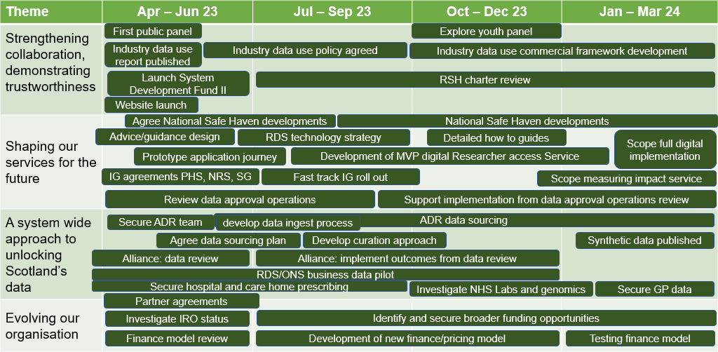

Medium-term (from April 2024)
In the 2024/25 fiscal year, we will launch the full Researcher Access Service. We will then focus on widening the range of service users and datasets we offer whilst further improving the speed and quality of data access services to researchers. During 2024 and 2025 our aim is to develop and launch new services and new valuable research data resources. We are planning to do the following:

Strengthening collaboration, demonstrating trustworthiness
- Work with other Scottish organisations to promote our services across the UK and internationally, and attract investment into Scotland
- Look to develop further partnership arrangements with other organisations in Scotland who provide data access services, both with the intention of federating data, and of enhancing the range of services available.

Shaping our services for the future
- Do market research to establish options and appetite for valuable new data services
- Roll out a ‘continuous improvement’ model to ensure services are constantly evolving based on user needs
- Commission and oversee further developments to the National Safe Haven. In particular,
  - develop approaches to automation of published dashboards driven by data held through RDS
  - examine approaches to automate privacy enhancement, disclosure control and other parts of the data access and linkage process
- Continue to take steps to standardise approaches to access to data for research across the Scottish public sector
- Implement new approaches to cohort creation and federated analysis that help researchers refine their asks for data and speed up data access.
- Decide whether, when and how to roll out a “measuring impact service”
- Scope a service to support organisations to make change happen through data driven innovation

A system wide approach to unlocking Scotland’s data
  - Further simplify Information Governance arrangements across Scotland to data access for research, and align with best UK and international practice in identifying and responsibly managing data risks.
  - Further simplify and standardise the process for data acquisition, in particular our offer to data owners to work with them, and support data quality improvements as part of the data preparation process.
  - Further automate the process of data ingestion with a focus on improving the timeliness and regularity of the data held through RDS.
  - Move forward with widening the range of data available for research based upon the requirements of Government through the ADR Scotland programme, the RDS strategy and a clear understanding of demand,
  - Establish further standing portfolio or cohort datasets based upon user feedback, aligning with existing data assets about Scottish people, places and businesses
  - Forge data federation and sharing arrangements with UK holders of data about Scottish people, places and businesses to connect these datasets with those provided by the Scottish public sector, in particular complete pilot work with the Office for National Statistics Integrated Data Programme.
  - Set up arrangements that enable linkages between people, places and businesses.
  - Make the production of synthetic datasets to researchers a standard approach.

Evolving our organisation
  - Establish further tangible examples of investment into Scotland because of the RDS offer. This requires RDS to work with Scottish Government, Scottish Trade International and several other partners to establish a data driven innovation offer to potential investors that is rooted in use of data for public benefit.
  - Transition to a business-as-usual footing using a sustainable approach to pricing and support for delivery partners.
  - Further broaden the range of funders for RDS
  - Continue to scan for international best practice in keeping data safe, acting in trustworthy ways, and speeding up access to data.

Budgets

Income
RDS will receive grants from at least three sources in the financial year.
- £5.1m from Scottish Government, being £3.3m for Y3 and £1.8m being balance of Y2 which was not claimed due to it being in advance of need.
- £600k for the ADR Scotland programme, and
- £30k to support public engagement work as part of the DARE-UK programme
- £5.73m Total income

Expenditure
The budget is to allow RDS to spend £6.5m on the following:
- Staffing £1.8m
- Project Spend £4.5m
- Operations/Governance £200k
Payroll figure assumes all 18 posts we had at end of February and 5 additional posts not yet started will be in puts throughout 2023-24. It is therefore likely that payroll will end up lower than this budget, though this will be balanced against any pay increase agreed during the year.
Project spending across our three main departments:
- Digital £2.2m
- Data £1.3m
- Partnerships £900k
A more detailed picture is shown on the next page

Year-end forecast
It is estimated that the trading year will result in a planned loss of £753k funded by agreed carried forward funds of £1.6m from the current financial year. This will result in an estimated funds balance of £836k in March 2024 of which £750k is our current reservice target, leaving £86k of free funds which could be added to spending or used to increase reserve target.

Reserves
Our current reserves policy is to hold six-month core expenditure based on Y2 budget. Depending on whether eDRIS support costs become a core cost we may want to consider increase our target by £250k a year to achieve £1.5m by 2026.

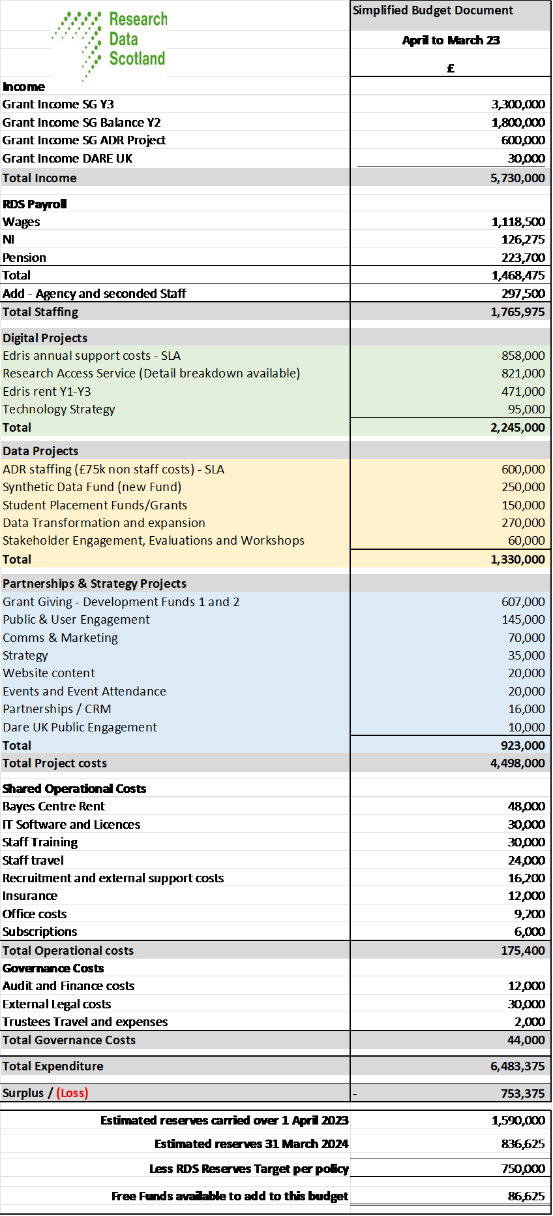

Measuring success
A set of initial KPIs were agreed by the Research Data Scotland Board and the majority of these have been reported on quarterly. Their intention is to help measure and manage progress against priorities for 2023-24 and the overall strategic outcomes RDS is aiming for.
The outcome measures 1b-d are tricky to measure. We have agreed to bring in a placement student to develop a way of collecting this information on a regular basis. This will be over summer 2023.

Research Data Scotland: Key performance indicators
1 | Outcomes | Latest | Target performance
 |  | 2022-23  Q3 | 2023-24  Q4 | 2024-25  Q4 | 2025-26  Q4
1a | Number of jobs created | In development | Agree when indicator fixed | Agree when indicator fixed | Agree when indicator fixed
1b | Published impact case studies | In development | Agree when indicator fixed | Agree when indicator fixed | Agree when indicator fixed
1c | No. citations to research from RDS data access | In development | Agree when indicator fixed | Agree when indicator fixed | Agree when indicator fixed
1d | No. publications from RDS data access | In development | Agree when indicator fixed | Agree when indicator fixed | Agree when indicator fixed
2 | Researcher service enquiries | 2022-23  Q3 | 2023-24  Q4 | 2024-25  Q4 | 2025-26  Q4
2a | Number of new enquiries per quarter | 59 | 80 | 100 | 133
2b | Projects supplied with data per quarter | 19 | 28 | 50 | 80
2c | Conversion rate: projects supplied with data as proportion of all enquiries | 32% | 35% | 50% | 60%
2d | Projects from non NHS or academic users | 3% | 5% | 7% | 10%
3 | Researcher service – delivery times | 2022-23  Q1-Q3 | 2023-24  Q1-Q4 | 2024-25  Q1-Q4 | 2025-26  Q1-Q4
3a | Average project duration - Initial inquiry to researcher access (median days) | 349 | 160 | 100 | 65
3b | Initial inquiry to first Data Access panel submission (median days) | 314 | 80 | 60 | 40
3c | First Data Access panel submission to latest data access panel approval (median days) | 34 | 30 | 20 | 15
3d | Latest Data Access panel approval to researcher access (median days) | 110 | 50 | 20 | 10
4 | Data offering | 2022-23  Q3 | 2023-24  Q4 | 2024-25  Q4 | 2025-26  Q4
4a | Number of datasets available via eDRIS | 36 | 41 | 47 | 55
4b | Number of synthetic datasets available | 0 | 1 | 3 | 5
5 | Partnerships / Communications | 2022-23  Q4 | 2023-24  Q4 | 2024-25  Q4 | 2025-26  Q4
5a | Website traffic  Page views  Users | 2,704  635 | 3,786  889 | To be agreed | To be agreed
5b | Social media  Engagement rate  LinkedIn unique visitors  Additional Twitter followers | 6%  308  132 | >2%  4313  1853 | To be agreed | To be agreed
5c | Newsletters  New subscribers | 91 | 127 | To be agreed | To be agreed
6 | Finance | 2022-23  Q3 | 2023-24  Q4 | 2024-25  Q4 | 2025-26  Q4
6a | % income from sourced other than Scottish Government | 0% | 12% | 25% | 51%

[Ends]

About Research Data Scotland
Research Data Scotland is unlocking the power of public sector data.
We help researchers find and make use of health, social care and administrative data to improve the lives of people in Scotland. Working in partnership, we do this by safely and securely widening the range of data available, creating new data assets and providing a single point of contact for effective access to public sector data.
We are a not-for-profit charitable organisation created and funded by Scottish Government. We are a partnership between Scottish Government, leading universities and public bodies, such as Public Health Scotland (PHS) and National Records Scotland (NRS).

www.researchdata.scot

@RDS_Scotland

Note that metric 3a isn't the sum of 3b-3d. Metrics 3a and 3d relate only to the projects where data was supplied in that period, whereas metric 3b relates to projects where the submission to the data access panel was made the that period, and metric 3c where data access panels approved projects in that period.
Annual [2021-22] median for the Health and Social Care Public Benefit and Privacy Panel.
Based on 10% inc. per quarter.
Maintain an engagement rate above 2% every quarter. Comparative sectors boast of an engagement rate of 1%.
This is an ambitious target of 10% growth per quarter and we expect to potentially reach a saturation point in the future, as we are targeting a small community.

