Pandemic preparedness review of data access approvals

Research Data Scotland

Published: November 2024


Note
The following report, published in November 2024, was originally created in August 2023. As such, it does not reflect some of the developments to Scotland’s data for research systems in the intervening period, such as the launch of the Researcher Access Service in April 2024.
Since the creation of the report, Research Data Scotland (RDS) has continued to evolve models of best practice based on the vision and principles identified in this document.
For more information about RDS’s work in the areas identified in the report and other recent developments, please visit our website.
Status: Final
Date: 30 August 2023
Authors: Roger Halliday / Hugh Wallace / Katie Oldfield

Table of Contents
Purpose and introduction 3
Glossary 4
The current national Scottish data approvals infrastructure 5
How the review was undertaken 6
What we heard 7
Vision for a future system 8
Recommendations 10
Appendix 1 – description of current approvals system, highlighting pain points
Appendix 2 – simple workflow of future approvals system
Appendix 3 – detailed journey map of future approvals system

Purpose and introduction
In August 2022, The Scottish Government Standing Group on Pandemic Preparedness published an interim report on steps required to put Scotland in a strong position to respond effectively to any future pandemics. A key element of the report was a recommendation “to build on Scotland’s existing data and analytics strengths to support proposals that advance the development of these as core infrastructure for future pandemics”. This work identified challenges around the speed, efficiency and consistency of decision making for approving data sharing as an area that needs to be addressed.
The Scottish Government data strategy for Health and Social Care, published in February 2023 reinforced this with a commitment: "We will explore how approvals for access to data for research might be accelerated through best practice and standard setting for the operation of data safe havens. We will also consider potential benefits of independent assurance of operating standards in conjunction with the National IG [Information Governance] Programme and our work on cyber security."
In March 2023, the Scottish Government Chief Scientific Advisor for Health, Professor Dame Anna Dominiczak, asked Research Data Scotland (RDS) to lead a review of approval processes for access to data for pandemics as a contribution to the Scottish Government’s Data for Pandemic Preparedness Oversight Group which she chairs.
The purposes for the review were to
- Provide an assessment of current and best practice of an aligned and efficient data access approvals systems for research and analytics from Scotland and elsewhere
- Provide a set of recommendations to the Scottish Data for Pandemic Preparedness Committee Oversight Group that describe an aligned and efficient data access approvals system for Scotland, and a route map for moving towards such a system. This should consider arrangements for industry use of data and the role of public engagement in decision making
A strong steer from the Oversight Group was that while the genesis of this ask might be on data governance for pandemics, there are wider systemic problems that need to be addressed in order to make Scotland resilient during future pandemics or other emergencies.
The current data approvals panels cover all forms of data sharing. These primarily are data sharing for research, allowing researchers to use public sector data to provide new insights that improve public policy, and data sharing for operations, allowing service management or delivery organisations to reduce cost or improve quality of public services.
It is understood that Data Governance is a complex space with many owners of data have their own approvals processes that have developed organically. There are arrangements for ethical scrutiny of some data sharing, and for scrutiny of methods use in some data driven research. As such, this work has considered data governance holistically.

Glossary
The Statistics Public Benefit and Privacy Panel: a group providing advice on the use of Scottish Government and some National Records of Scotland data. This is primarily for research and statistical purposes.
The NHS Scotland Public Benefit and Privacy Panel for Health and Social Care: a group providing advice on the use of NHS Scotland and some National Records of Scotland data. This is both for research and operational purposes.
The Community Health Index Management Board: a group providing advice to the Chief Medical Officer for Scotland and the Directors of Public Health on the use of data from the Community Health Index. This is both for research and operational purposes.
Panel chair: ensures that the panel delivers on its purpose, meeting any performance targets or obligations and work to current legislation, policies, public views and precedents, and that the panel is adequately resourced and qualified. They are the final arbiter of submitted applications.
Panel manager: assists the panel chair in ensuring the panel delivers on its purpose. They liaise with applicants and provide information about the applications to panel members. They also support panel members in ensuring they are working to current legislation, policies, public views and precedents.
Panel member: the role of panel member (sometimes called panel participant) is to review applications for access to data, using their experience to provide views on the balance between privacy protection and societal benefit that is likely to accrue from sharing data.
Trusted Research Environments: not-for-profit highly secure computing spaces that act as data custodians and provide remote access to data for approved researchers. Trusted Research Environments (TREs) can also be called Data Safe Havens and Secure Data Environments. In Scotland, they are independently accredited to ISO 27001 standards and the National Safe Haven is accredited by the UK Statistics Authority. In Scotland there are five TREs, namely the National Safe Haven, West of Scotland Safe Haven, Health Informatics Centre (HIC), DataLoch and Grampian Data Safe Haven (DaSH). The latter four listed here are collectively known as the Scottish Regional Safe Havens.
Five Safes framework: The international best practice for helping make decisions about making effective use of case level sensitive data. The ‘safes’ describe five factors needed to minimise risk of poor outcomes from data sharing, and are:
Safe projects: Is this use of the data appropriate, lawful, ethical and in the public interest?
Safe people: Can the user be trusted to use it in an appropriate manner?
Safe data: Does the data itself contain sufficient information to allow confidentiality to be breached?
Safe settings: Does the Safe Haven limit unauthorised use or mistakes?
Safe outputs: Is the confidentiality maintained for research outputs coming out of the Safe Haven?

The current national Scottish data approvals infrastructure
There are three national Scottish approvals panels: the NHS Scotland Public Benefit and Privacy Panel for Health and Social Care, the Statistics Public Benefit and Privacy Panel, and the Community Health Index Management Board. Appendix 1 describes current arrangements from the perspective of someone applying for access to data.
There are also a range of approval panels associated with other TREs in Scotland, and other data controllers. This includes the UK Research Accreditation Panel that provides advice to the Office for National Statistics on use of its data, including about Scottish people and businesses.
In addition, all research undertaken by NHS or academic research teams needs ethics approval under panels set up by individual organisations, and UK Research Councils scrutinise research funding applications around methods proposed.

How the review was undertaken
The arrangements for data approvals ultimately need to be legal and be acceptable to the public and to the owners of data. They also need to work for those who want to share data. Any solution therefore needs to balance the views of these different stakeholder groups. The review focused on listening to this range of perspectives.
To do this, we were able to draw upon an extensive set of user research with those who want to access data owned by others, particularly the experiences of researchers. We also drew upon the outputs from a wide range of public engagement exercises surrounding data access approvals. The findings from this are woven through the paper.
We complemented this by appointing Capgemini to conduct interviews with managers and members of the three national Scottish approvals panels, and to review and speak to organisations outwith Scotland involved in data approvals.
To complement this, we also analysed two reviews by the Public Benefit and Privacy Panel for Health and Social Care: one on the experiences in the Covid pandemic and another from 2018.
The findings and conclusions have included feedback from the Statistics PBPP, and CHI management Board described above, and a small group of relevant Scottish Government officials.
The authors thank those panel members and managers who gave their time to support the review, researchers who shared their experiences in applying for data through the panels, to Capgemini for their insights and Scottish Government officials who provided feedback to set the scope and objectives for the review and throughout the review itself.

What we heard
From a combination of outputs from public engagement exercises and interviews with panel members, it was clear that there needed to be a review of requests for reuse of data, to test the reasonableness of the proposed data share i.e. “is the proposed use of data likely to have the support of a typical person?”. It was suggested that this should include an ethics review. Members of the public wanted transparency of who applied for use of what data, as well as a description of how this will lead to public benefit. They expected a review to include members of the public and experts at appropriate times, for example a researcher on methodology, and a medical professional for ethics of using health data. There is currently no consistent way of engaging member of the public in approvals processes.
Concerns were shared from researchers and others wanting to share data that the process is too slow, and the amount of work they need to do to get approvals from panels is disproportionately high. There was a similar message from panel managers and members that there is significant work in considering applications, which is challenging for panel members as this is a role in addition to their regular day job. In particular, panel managers and members thought that the rapid approvals process that happened during the Covid pandemic would not be sustainable without an increase in resources (including the number of panel members).
Indeed, panel members said that, given the volume of information that was presented to them, they sometimes found it difficult to spot the problems. They each had a mental checklist of assurances they sought, but that this was based upon their experience rather than a defined list. Linked to this, researchers often reported that they got advice that was contradictory for different applications, and that at times they felt that the panel took a different view from the advice they had been given in preparation of the application.
The expertise that is needed to make assessments of risk versus benefit are wide ranging given the range of elements involved. Researchers felt that panels sometimes provided advice on areas where they lacked expertise, in particular on data security.
Researchers explained that there were multiple approvals required, often covering the same ground (and occasionally giving conflicting advice). They said that different panels often asked for information in slightly different ways. They said this was frustrating because it added cost and unpredictability to the delivery of their work.
Panel members expressed concern that they didn’t always get the information from applicants that they needed to make a suitable decision, which meant both rework for the applicant and for the panel. Conversely, researchers felt that the controls in place aren’t proportionate to the risks in all cases, particularly where there are minor amendments to projects.
A theme that came through strongly was the need for diversity on panels, and consideration of equalities as part of the scrutiny process. There was an overall sense from all parties that the status quo is not sustainable and needs to change, that there is significant potential for efficiency savings whilst maintaining public support for the reuse of data.
We examined approaches to how other assessment and approvals processes are happening elsewhere in the UK. None of the approaches thought they had the ideal solution, though all had some components worth emulating. Our work therefore looked at the elements of systems in place that in combination come closest to the desired outcomes described above.

Vision for a future system
Any data governance system needs to enable data sharing and reuse of routine public sector data where this delivers benefit to the public as quickly as possible.
A future system should be able to operate at a significantly larger scale leading to enhanced public value. More data sharing should mean reduced cost in public service delivery through reuse of data. It should mean that there are a wider range of researchers and analysts conducting research using routine public sector data, and a greater number and complexity of research projects using routine data. It should boost inward investment in research in Scotland through academia/industry and ensure the people of Scotland feel their privacy rights are respected.
This approach needs to ensure it is quicker from application to approval granted with less work for researchers, approvals panel managers and members. It needs to minimise the risk that data could be used in situations where it is not in the public interest and ensure that people will not be reidentified through their data being shared (unless specifically permitted).
Ultimately, the assessment process needs the support of data controllers, who will want to ensure public support for that approach. However, for the objectives above to be met, the process needs the support of those wanting to reuse data in the public good. They need to feel they are being treated fairly, and as such, the system needs to learn by precedent, and be consistent whichever panel is involved.
It is important that both data controllers and those wanting to reuse data understand the process and their responsibilities, and so keeping solutions as simple as possible, backed up by clear, straightforward advice and guidance is essential.
Public trust is paramount in reuse of data, and a key demonstration of trustworthiness is that there is transparency about who is applying for data reuse, what for, and for how long. This information needs to be proactively published and easily accessible.
Arrangements need to be built upon a public view of reasonableness for any data sharing. The proposal is that panels should have appropriate public representation either with public members on review panels themselves or through other methods of engagement. Review of applications should be proportional to the projects themselves taking into account factors such as risk and precedent. Where smaller panels are used projects should always be supported by a minimum of two panel members
Resources are limited, so supporting those wanting to reuse data to get the right information for assessment and working with a principle of “one project, one review” should minimise the effort. An important component here is to standardise where possible and automate where this will not risk data security or public trust, though the public message was clear that there needs to be human decision-making as part of the assessment.
A realistic ambition is that, following the recommended changes, it takes an average of no more than two weeks from submitting an application for data to a decision for requests where there is already a precedent. To achieve this, we need an aligned, consistent, open and transparent scrutiny process facilitated by a secure, scalable, user-centred technology solution. This will strike a publicly supported balance between safeguarding the privacy of all people in Scotland and the fiduciary duty of Scottish public bodies to make the best possible use of the data collected.
The Five Safes framework is accepted as best international practice, as is the principle of proportional governance. In the context of research, this means researchers qualified in safe data handling is a must have, and that working in TREs is preferred because this meets the ‘safe settings’ element of a review. Indeed, while an important first step is alignment across Scotland, alignment across the UK is also desirable as there are many research projects that look to bring together data from the UK nations.

Recommendations
Having effective Information Governance (IG) processes is a necessary component of getting data shared at pace, but is only part of the solution. It is also vital to have effective data discovery tools, streamlined application procedures, and quick access to data once approvals have been made.
In the research space, Research Data Scotland is making a range of changes to the system for data access with a focus on reducing the time and complexity from a researcher who is interested in sharing data to them analysing that data.
There is significant work happening on other elements of IG that will support the changes proposed here, for example the development of a code of conduct for Information Governance. There is also a range of activity on public communications and engagement that is trying to explain the benefits of data sharing, to secure an informed public view.
The recommendations fall into seven themes:
- Passporting elements: principle "One project, one review"
A significant frustration for those wanting to share data is the ask to get multiple approvals. This comes from a misalignment of processes and, at times, a lack of trust across the system. We also heard the public clearly say that part of the reasonableness test was an assessment of ethical issues.
There are existing ethics review processes in the NHS and in universities for research. While this review does not cover data ethics, there is the case for other projects to do a self-assessment ethics review, which for statistical projects can draw upon the UK National Statisticians’ Ethics Committee for advice. Indeed, the UK Statistics Authority has an established self-assessment ethics review that works well. This includes an assessment of bias coming from use of data.
For research, when applying for funding the methodology proposed in academic projects is scrutinised. However, there will be research projects where this is not done. As such, part of the scrutiny of applications for research use should be either assurance is provided that assessment of methods has been done, or that this is built into the panel application.
There are also projects that require multiple approvals. For example, a data linkage research project on interaction of mental health and qualifications would currently require approvals from both the health and statistics PBPPs. To handle these cases, an agreement between panel managers should be established to agree the route for assessment. This will need to involve the relevant domain knowledge, as per section five below.
The proposal is therefore that the national IG panels move to a process where each application has a single ethics review, and a single review of privacy vs. public benefit.
While the scope of this review is on the national IG panels, there are times where data sharing across multiple data controllers, for example NHS Boards, requires approval from each data controller. In delivering the changes proposed above, it will be important to connect to the work, led by the Scottish Regional Safe Havens to develop a delegated approvals process aligned to the arrangements for Scotland as a whole. Indeed, broad alignment of approach is needed to achieve trust across data controllers, but it would also lead to the potential to collaborate on the other recommendations and make the system much more straightforward from an applicant's perspective.
It is important to recognise that there may be specific data controllers who will struggle, at least initially, to support the principle of “one project, one review.” It will be important for the panels to work collaboratively to involve the data controller appropriately in decision-making, and demonstrate trustworthiness in how that runs, for example by using audit as outlined in section five below.
- Creation of a digital assessment and approvals process
A digital solution that dovetails with other core functions of a data access service is critical to reducing the time and complexity of assessment and approvals processes, eliminating unnecessary manual work, and opening up the opportunity to automate and implement innovative features.
Three important elements of the digital process are:
- Implement a fully digitised solution to incorporate a comprehensive scoring assessment framework, enabling panel managers and panel members to make data-driven decisions
- Put into practice a consistent framework and a single application repository to help improve the speed and effectiveness in decision making
- Alleviate manual workarounds and promote automation by targeting and prioritising the alleviation of ‘pain points’ in the current processes, and seeking to gain efficiencies through improved business logic
- Application process: reducing time to complete and getting right first time
Making improvements to the application was flagged by researchers, panel managers and members. Significant progress has already been made to review existing data application processes and to start to develop forms and business logic based on user needs. This work is being taken forward by RDS as it prioritises the phased delivery of a new Researcher Access Service.
While the next specific development phase will focus on the development of a ‘minimum viable product’ for researchers to apply for datasets, the following significant tranche of development should focus on the assessment and approvals process.
- Reviewing the different application forms, mapping how each section of the data application form is used in decision making – currently this is unclear from the guidance provided
- Move some to RAG rating as per Stats PBPP - moving the form from open ended questions to fixed response where possible, for example legal basis. This would potentially allow for future automation
- Align with UK standard as proposed by HDR, and other best practice guidelines, where possible
Digitising the application form can offer some additional functionality to create efficiencies, such as:
- Option to develop new training materials (e.g. short videos, animations) to explain nature of research
- Automated checking that people have IG qualifications (HDR UK developing a researcher single sign-on)
- Pre-fill of info for amendments
- Export info to template Information Governance documentation if that is required
For applications through the HSC PBPP, the eDRIS team in Public Health Scotland play a key role supporting applicants to choose the data they need, and to compile the information needed for approval. Introducing a passport style “check and send” service based on caselaw could reduce the risk of the panels not getting the information needed for decision making.
To get the system working well it is vital that researchers provide the information needed for decision making first time. To support this, a joint initiative should be undertaken to provide updated training packages and reference materials to panel applicants (and academic supervisors) building on existing information.
- Triage: getting greatest value from the panel
Triage is the process by which panel managers make decisions on how to handle a data sharing application. There are different processes used across the three national panels. The Statistics PBPP has a semi-automated risk assessment built into the initial application that is then triaged to an appropriate tier of decision making. This fits well with the design principle of automating where this does not compromise data security or public trust and should be developed across panels.
There are elements of the assessment that are objective and definitive and that can be resolved without seeking a view from a wider group. As such, the panel manager should ensure (and provide assurance to the panel) that:
- There is a legal basis for the proposed data share
- The people who will access the data are appropriately qualified
- An ethics assessment has happened – either a formal ethics committee or a self-assessment
Some comments heard during the review suggested that, given the specialist nature of the advice needed here, a data security expert is employed to provide all the panels with impartial advice. This would not be needed where this is a research project taking place is an established UK TRE. However, where advice is needed, this would need to be provided within five working days of each application. Therefore, additional call off advice would be needed at times the data security expert was not around.
- Panel operations: focusing the ask of panel members using proportionate risk
Each panel works with different tiers that represent different levels of complexity and risk for projects. The recommendation is for four tiers with the decision of which tier to assign to, based on a risk scored application:
- Low risk with decision and sign off by two people: a panel manager and member of eDRIS. Decisions would be due within three working days of application submission. If there is disagreement, this is escalated to tier 1
- Medium risk with decision and sign off by an online group. Panel members would be presented with material from the application and asked for comments within 5 working days of application submission. There would be a group of at least four people assigned to each application - mix of expertise: at least one domain expert, two public members, and someone with IG expertise. The panel manager as chair would decide on the outcome from the comments made. They would have the option of seeking a view from tiers 2 or 3
- Higher risk with decision and sign off by online senior group. Again, panel members would be presented with material from the application and asked for comments within five working days of application submission. There would be a group of four people assigned to each application. This group should comprise of a Caldicott Guardian (for health data or Information Asset Owner for other data), a domain expert (such as an Academic for a research project) and two public representatives, with the Panel chair analysing the comments and using this to make a decision
- Precedent setting cases. There would be a single group representing all the national panels. This would meet in person, and draw upon IG expertise, domain experts, panel chairs with half of the group being public representatives. It would develop a pool of experts who could provide additional advice on the quality of the science of a proposal where this is very complex/cutting edge, for example around artificial intelligence. The applicant would attend the group to do a Q&A (as per recommendation of HSC PBPP review)
The criteria for allocation to each of the tiers would need to be established, engaging the public in its development. This can be built upon the Statistics PBPP and UK Statistics Authority semi-automated triage approaches.
Researchers expressed frustration in having to specify exactly which datasets and variables they need ahead of their research being undertaken. This means they often need to make amendments when their research leads to related areas of exploration. The creation of synthetic datasets can help this but won’t eliminate this challenge.
There are a non-trivial minority of the population who are instinctively more nervous of their data being used by industry. As such, applications that have a commercial element to them should be assessed by tier 2 (or tier three if they are precedent setting).
In addition, researchers were also concerned that they had to apply for use of data on a project-by-project basis. Having the option of applying for the datasets that would underpin a programme of research as a single application would lead to significant efficiencies in creating a data resource once for multiple projects related under a common objective.
Each panel member will bring their own expertise to a panel, but also their own biases. To support consistency of decision making, decisions for one in every 20 projects should be reviewed by the tier above (and in the case of tier 2 by another assigned panel of four people). As described above, there should be additional guidance for panel members and access to historic cases to support their decision. In addition, there should be training provided for panel members as part of their induction.
Panel members would be asked to provide views on four aspects of an application
- Is there public benefit?
- Does the project look feasible in delivering its aim?
- Are any privacy implications mitigated?
- Will this project lead to any other harms?
Through the digital application form, panels would be provided with the information from the application required to make a decision on the questions above only. The three panels should collaborate on a shared history of case studies and principles for what will – and won’t – be approved, building on good practice in the HSC PBPP. The ambition in designing this is that the view on application at tiers 0, 1 and 2 should be possible within 15 mins.
These changes should ensure that non-precedent setting applications are dealt with quickly, and those setting precedent have significant scrutiny which will take time. In a pandemic or other emergency situation, it may be important to make quick decisions on a precedent setting application. As such, the tier 3 group would need to be established in ways where it is possible to bring it together at short notice in emergency situations on an ad hoc basis for important asks.
- Transparency
An important element of public trust is in the having published information about who applied for use of what data, as well as a description of how this will lead to public benefit. The recommendation is to develop a standard data use register by panels and TREs, building on the work of HDR UK. And that all panels are transparent about their membership and ways of working.
- Governance and finance
The three panels have staff working in different organisations and with different accountabilities. While there is some coordination across the panels, the proposals above require a different level of collaboration. Having a single tier 3 panel, and single application process, will require the panel managers and chairs to develop ways of working to deliver this. The review is not proposing merging the panel management teams.
We have seen some good continuous improvement both in Scotland and elsewhere. As the changes are made, it will need a set of Key Performance Indicators that support that improvement.
The proposals made in this paper should reduce the overall cost to the public purse of the approvals processes, through reductions in rework, and efficiencies in the time taken to scrutinise applications. These should be felt by researchers, and panel members. However, there are new costs suggested here, primarily borne by panel managers, who are expected to take a more involved triage and assessment role, and by paying for expertise in assessments on data security and public engagement.
There are also some transitional costs in making the changes to the new system. As such, a short business case will need to be made for the transitional funding and operations of the new system.

About Research Data Scotland
Research Data Scotland (RDS) is making it faster and simpler for researchers to access public sector data for research.
We help researchers find and make use of health, social care and administrative data to improve the lives of people in Scotland. We do this by safely and securely widening the range of data available, creating new data assets and providing a single point of contact for effective access to public sector data.
We are an independent charity created and funded by Scottish Government. We work in partnership with Scottish Government, leading universities and public bodies, such as Public Health Scotland (PHS) and National Records Scotland (NRS).

www.researchdata.scot

@RDS_Scotland

Appendix 1 – description of current approvals system, highlighting pain points
To request a high-resolution version of this document, please contact us.
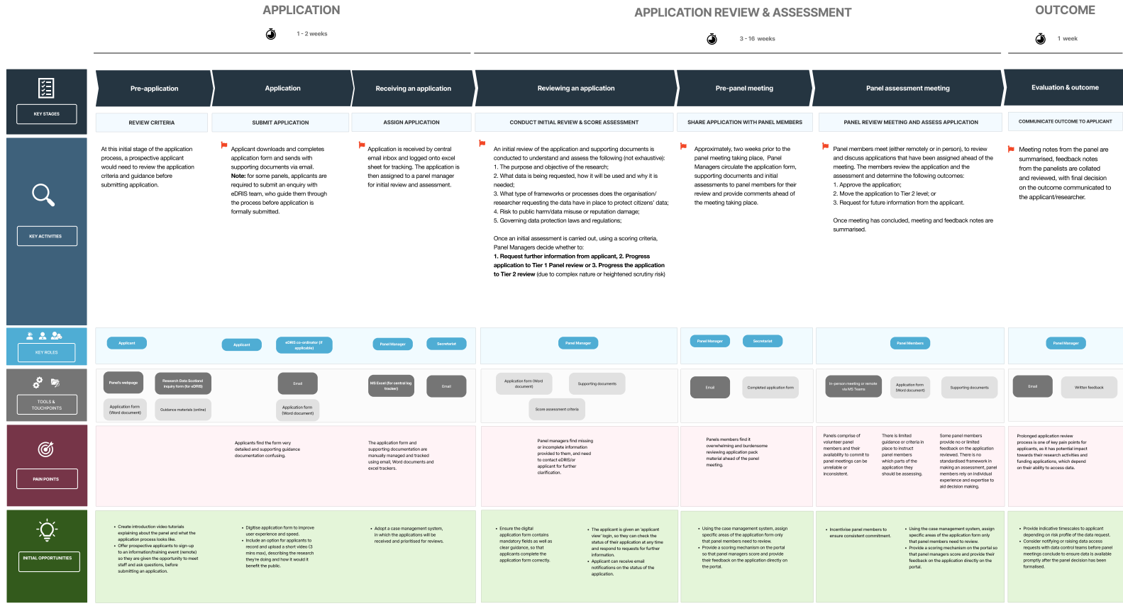

Appendix 2 – simple workflow of future approvals system
To request a high-resolution version of this document, please contact us.
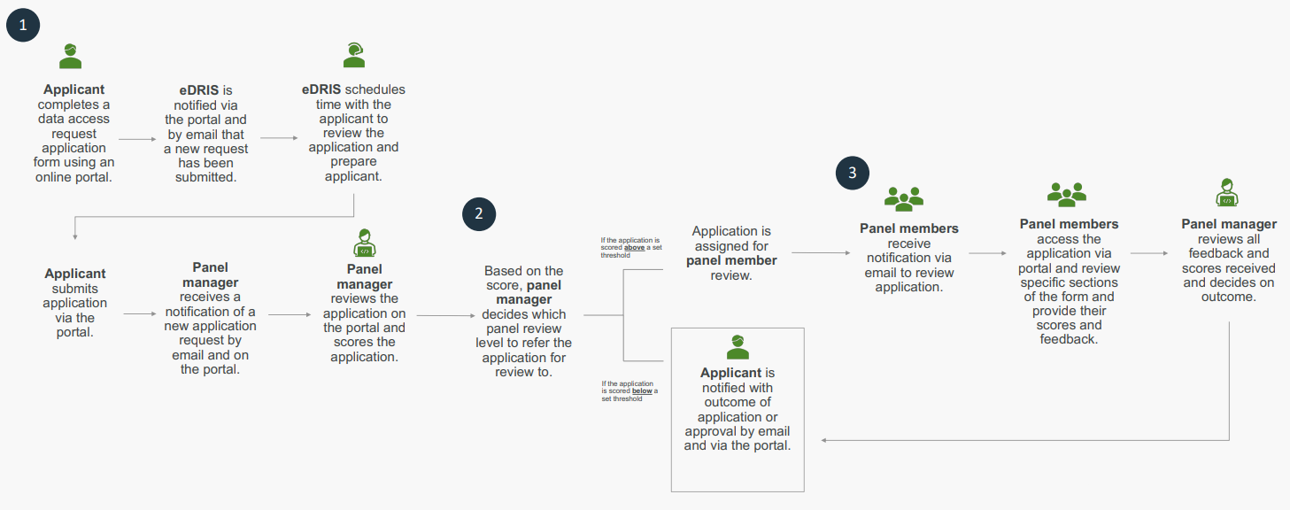

Appendix 3 – detailed journey map of future approvals system
To request a high-resolution version of this document, please contact us.
